2.39: a) From Eq. (2.13), with 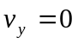and 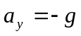,
which is probably too precise for the speed of a flea; rounding down, the speed is about 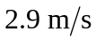.
b) The time the flea is rising is the above speed divided by g, and the total time is twice this; symbolically,

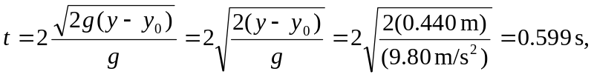
or about 0.60 s.

